Step 1 – Install OpenVPN
- On the PC that you will be using to access the server download the .exe fie from this link:
https://sync.vmcloud.ca/shares/file/Rx8MNACOYuK/
- Run the .exe 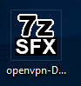
- In the pop up that appears click on “More info” link 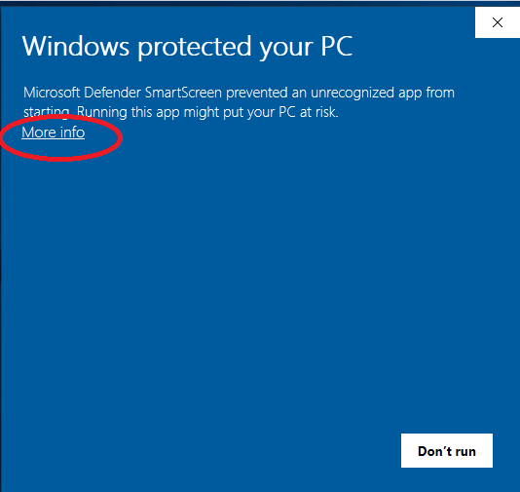
- Then click on 
- Go through the steps of installation
- After it installs the OpenVPN GUI you will be prompted to install the OpenVPN Installer
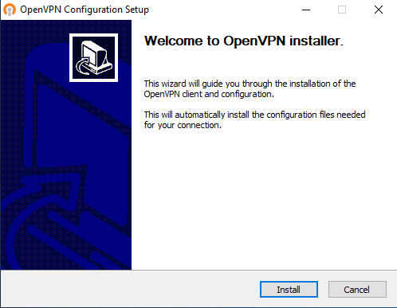
  - Click on Install and follow the steps until this is fully installed on your PC

Step 2 – Connect to OpenVPN
- In the taskbar of your PC will be the OpenVPN icon
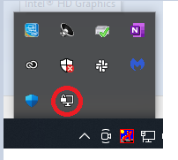
- Right click on this icon and then click on “Connect”
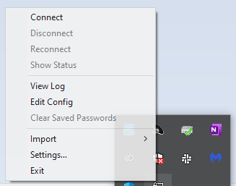
- Enter your unique OpenVPN user name and password assigned to you
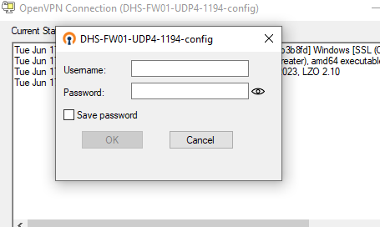
- Once successfully connected in the task bar icon will show as connected 

Step 3 – RDP
- Now that you are connected to the server by OpenVPN proceed to RDP onto the server
- Per usual process open Remote Desktop Connection 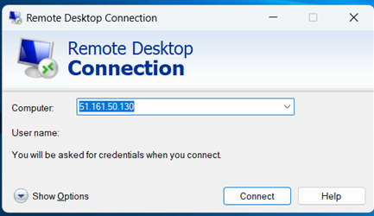
- Click on “Connect” as the computer IP is still 51.161.50.130
  - Even though new server IP is different still use 51.161.50.130 as this is a tunnel IP address now
- In the pop up that appears click on More choices
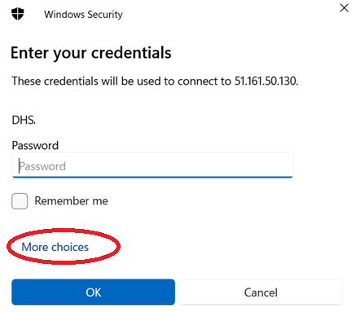
- Click on and then you will be prompted to enter your new RDP user name and password:

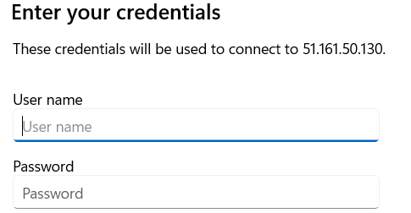

- Once inputted then connect to the server and per regular process it will open the server desktop
- Please note that this is now your own unique profile on the server so by default it will look like nothing is there. However you just have to open the applications you need and save shortcuts to the desktop
- After completed your work on the server disconnect from OpenVPN. Do so by right clicking on the OpenVPN icon in the taskbar and then click on Disconnect 